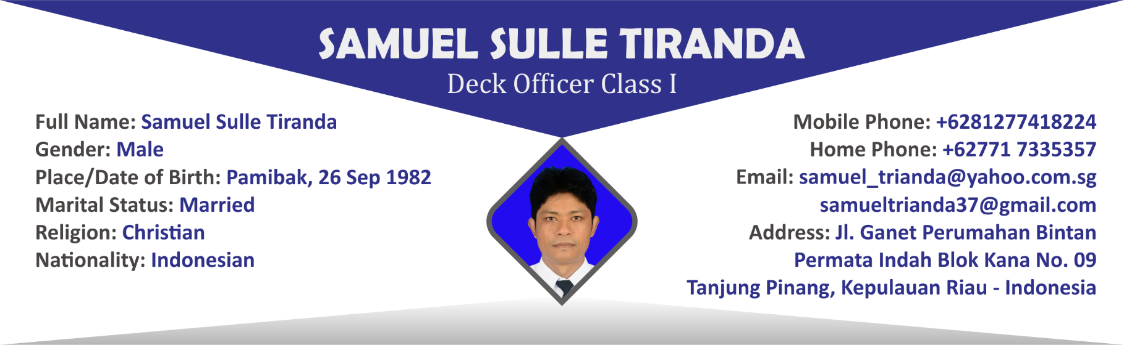

|  |  |  |  |
| --- | --- | --- | --- |
|  | | | |
| Document | **Number** | **Place / Date of Issued** | **Date of Expire** |
| Passport | B 5577300 | Tanjung Pinang, 27 Dec 2016 | 27 Dec 2021 |
| Seaman Book | E 079584 | Jakarta, 24 May 2016 | 22 May 2021 |

|  |  |  |
| --- | --- | --- |
|  | | |
| Certificate | **Number** | **Place / Date of Issued** |
| Deck Officer Class I | 6200542633N10116 | Jakarta, 03 Jun 2016 |
| Endorsement Class I | 6200542633N10116 | Jakarta, 10 Jun 2016 |
| GMDSS Radio Operator | 6200542633G10116 | Jakarta, 23 Feb 2016 |
| COE | COE-D0152592 | Singapore,19 Jan 2018 |

|  |  |  |
| --- | --- | --- |
|  | | |
| Certificate | **Number** | **Place / Date of Issued** |
| Basic Safety Training | 6200542633011116 | Jakarta, 12 Feb 2016 |
| Medical First Aid | 6200542633071116 | Jakarta, 15 Feb 2016 |
| Survival Craft and Rescue Boats | 6200542633041116 | Jakarta, 12 Feb 2016 |
| Advanced Fire Fighting | 6200542633061116 | Jakarta, 15 Feb 2016 |
| Medical Care On Board Ship | 6200542633080716 | Jakarta, 28 Apr 2016 |
| Radar Simulator | 6200542633030716 | Jakarta, 28 Apr 2016 |
| ARPA Simulator | 6200542633020716 | Jakarta, 28 Apr 2016 |
| Bridge Resource Management | 6200542633230716 | Jakarta, 28 Apr 2016 |
| Operational Use For ECDIS | 6200542633280716 | Jakarta, 07 Apr 2016 |
| Ship Security Officer | 6200542633240116 | Jakarta, 04 Apr 2016 |
| Basic Training For Oil & Chemical Tanker | 6200542633390116 | Jakarta, 18 Apr 2016 |
| Advanced Training For Oil Tanker Cargo | 6200542633410116 | Jakarta, 02 May 2016 |
| General Operator Certificate | G 051621/SOU/T/IV/2016 | Jakarta, 20 Apr 2016 |
| International Safety Management Code | 3200/ISM CODE/IIV/STIP-16 | Jakarta, 22 Apr 2016 |
| Harbour Craft Master | ISC-HM 06-0097 | Singapore, 27 Sep 2006 |
| Tug Master Training & Assessment Course | ISC-TUG 07-0037 | Singapore, 17 Apr 2007 |
| Oil Spill Control Course | STET/OSC/226 | Singapore, 21 Sep 2006 |

|  |  |  |  |  |  |  |  |
| --- | --- | --- | --- | --- | --- | --- | --- |
|  | | | | | | | |
| Name of  Vessel | **Type of**  **Vessel** | **GRT** | **Rank** | **Period of Service** | | **Company** | **Flag** |
| **From** | **To** |
| MV Sapphire | ASD Tug | 246 | Ch Officer | 22.01.2005 | 25.06.2005 | PSA Marine | Singapore |
| MV Noble Knight | ASD Tug | 246 | Master | 25.06.2005 | 05.07.2006 | PSA Marine | Singapore |
| MV Swift | ASD Tug | 291 | Master | 05.07.2006 | 16.02.2008 | PSA Marine | Singapore |
| Mv Star Discovery | ASD Tug | 327 | Master | 16.02.2008 | 01.10.2008 | PSA Marine | Singapore |
| MV Swift | ASD Tug | 291 | Master | 01.10.2008 | 13.03.2010 | PSA Marine | Singapore |
| MV Steady | ASD Tug | 291 | Master | 24.03.2010 | 29.05.2011 | PSA Marine | Singapore |
| Lamnalco Teal | AHT/ASD Tug | 454 | Master | 24-06-2011 | 24-10-2011 | Lamnalco Group | Cyprus |
| Lamnalco Teal | AHT/ASD Tug | 454 | Master | 06-01-2012 | 01-05-2012 | Lamnalco Group | Cyprus |
| Smit Rio Muni | ASD Tug | 374 | Master | 29-04-2013 | 03-09-2013 | Smitlamnalco Group | Bahamas |
| Smit Bioko | ASD Tug | 374 | Master | 26-12-2013 | 13-04-2014 | SmitLamnalco Group | Bahamas |
| Smit Bioko | ASD Tug | 374 | Master | 18-05-2014 | 03-09-2014 | SmitLamnalco Group | Bahamas |
| Smit Boiko | ASD Tug | 374 | Master | 27-10-2014 | 20-01-2015 | SmitLamnalco Group | Bahamas |
| Smit Rio Muni | ASD Tug | 374 | Master | 17-02-2015 | 10-05-2015 | SmiLamnalco Group | Bahamas |
| Smit Bioko | ASD Tug | 374 | Master | 15-06-2015 | 22-09-2015 | SmitLamnalco Group | Bahamas |
| Smit Rio Muni | ASD Tug | 374 | Master | 21-10-2015 | 20-12-2015 | Smitlamnalco Group | Bahamas |
| Smit Bioko | ASD Tug | 374 | Master | 05-06-2016 | 22-08-2016 | Smitlamnalco Group | Bahamas |
| Smit Rio Muni | ASD Tug | 374 | Master | 24-09-2016 | 04-12-2016 | Smitlamnalco Group | Bahamas |
| Smit Bioko | ASD Tug | 374 | Master | 05-01-2017 | 23-03-2017 | Smitlamnalco Group | Bahamas |
| Smit Rio Muni | ASD Tug | 374 | Master | 24-04-2017 | 09-07-2017 | Smitlamnalco Group | Bahamas |
| SL Egret | AHT/ASD Tug | 484 | Master | 24-08-2017 | 30-11-2017 | Smitlamnalco Group | Cyprus |
| SL Egret | AHT/ASD Tug | 484 | Master | 18-01-2018 | 22-03-2018 | Smitlamnalco Group | Singapore |
| SL Egret | AHT/ASD Tug | 484 | Master | 14-05-2018 | 06-08-2018 | Smitlamnalco Group | Singapore |
| SL Egret | AHT/ASD Tug | 484 | Master | 01-10-2018 | 17-12-2018 | Smitlamnalco Group | Singapore |
| SL Egret | AHT/ASD Tug | 484 | Master | 18-02-2019 | 04-05-2019 | Smitlamnalco Group | Singapore |
| SL Egret | AHT/ASD Tug | 484 | Master | 08-07-2019 | 29-09-2019 | Smitlamnalco Group | Singapore |
| SL Egret | AHT/ASD Tug | 484 | Master | 22-12-2019 | 06-03-2020 | Smitlamnalco Group | Singapore |

*Certificate Online Search:* [*www.pelaut.go.id*](http://www.pelaut.go.id) *& reor.postel.go.id*