
PERSONAL INFORMATION
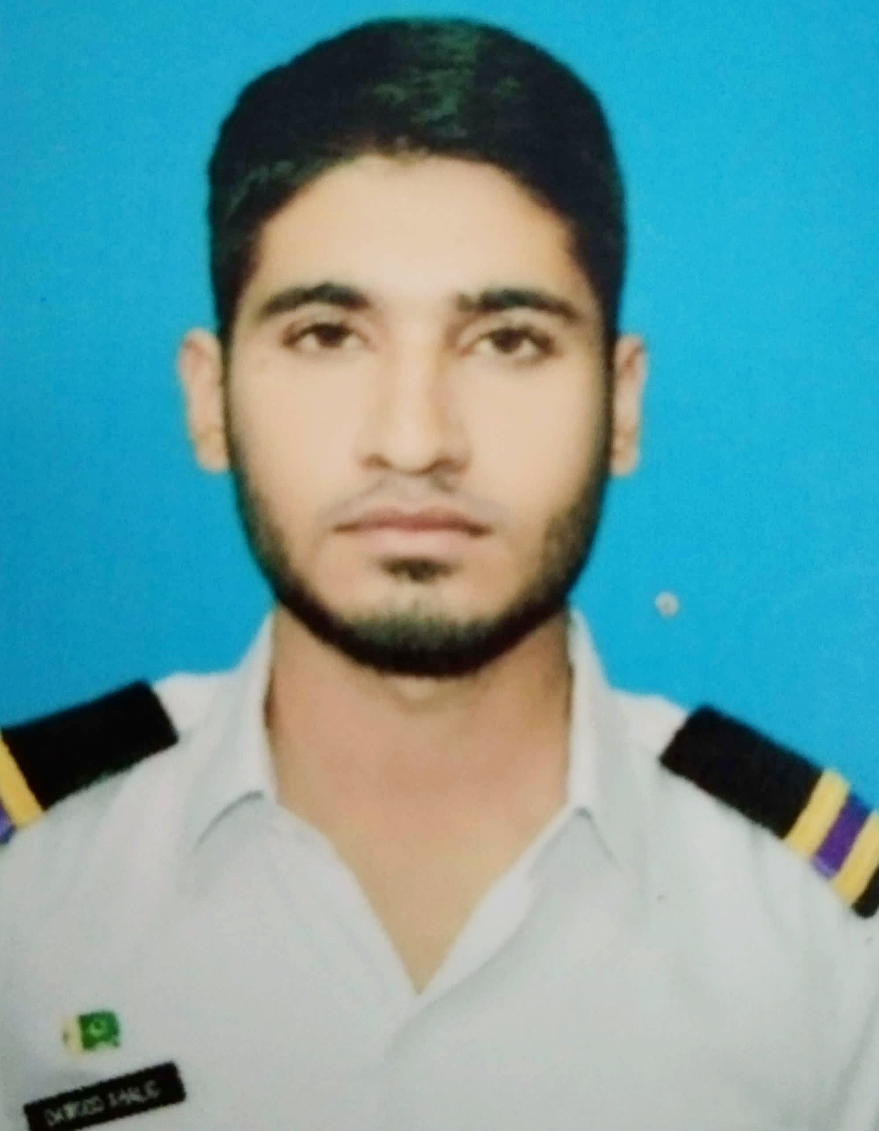
POST APPLIED FOR: ENGINE CADET
NAME: MUHAMMAD DAWOOD KHALID
FATHER NAME: MUHAMMAD KHALID MASOOD
DATE OF BIRTH: 19/03/1996
NATIONALITY: PAKISTANI
PERMANENT ADDRESS: CHAK NO.541 E/B,MOGI POST OFFICE SAME,TEHSIL
BUREWALA,DISTRICT VEHARI.
CONTACT NUMBER(s): +92-3013077074
EMAIL: dawoodch21@gmail.com

OBJECTIVE: To work as an Engine Cadet in merchant shipping company that will enable me to show professional skills. In addition, to be highly motivated, enthusiastic and professional cadet that always accepts new challenges.
EDUCATIONAL DETAILS:
QUALIFICATION | YEAR | INSTITUTE/BOARD
ASSOCIATE DEGREE IN MARINE ENGINEERING(HND) | 2017 | PAKISTAN MARINE ACADEMY
HSSC | 2015 | BISE SAHIWAL
SSC | 2012 | SANABIL EDUCATIONAL COMPLEX
DETAILS OF TRAINING COURSES:
TRAINING COURSE/CERTIFICATE | CERTIFICATE  NUMBER | DATE OF ISSUE | INSTITUTE
PROF. IN BASIC TRAINING FOR OIL AND CHEMICAL TANKER CARGO | 002317 | 08/12/2017 | PAKISTAN MARINE ACADEMY
PROF. IN FIRE PREVENTION AND FIRE FIGHTING | 0028160 | 08/12/2017 | PAKISTAN MARINE ACADEMY
PROF. IN ELEMENTARY FIRST AID | 11363 | 08/12/2017 | PAKISTAN MARINE ACADEMY
PROF. IN PERSONAL SAFETY AND SOCIAL RESPONSIBILITIES | 016015 | 08/12/2017 | PAKISTAN MARINE ACADEMY
PROF. IN PERSONAL SURVIVAL TECHNIQUES | 029444 | 08/12/2017 | PAKISTAN MARINE ACADEMY
DETAIL OF OTHER DOCUMENTS:
DOCUMENT | DOCUMENT NUMBER | DATE OF ISSUE | DATE OF EXPIRY
NATIONAL IDENTITY CARD | 37406-7664147-3 | 10/10/2014 | 10/10/2024
PASSPORT | RC4141471 | 05/08/2019 | 03/08/2024
SAEFARERS IDENTITY DOCUMENT | PAK024256 | 02/10/2019 | 01/10/2024
SEAMAN SERVICE BOOK | 025416-EO | 02/10/2019 | 01/10/2029
COMPUTER SKILLS: MS OFFICE, DIGITAL MARKETING, CREATIVE WRITING, GOOD COMPUTER HARDWARE AND SOFTWARE SKILLS
WORK EXPERIENCE: ONE YEAR INTERNSHIP AT PAKISTAN NATIONAL SHIPPING
CORPORATION (PNSC).
- MACHINE SHOP.
- WELDING SHOP.
- OVERHAULING AND DISMANTLING OF MARINE ENGINES.
LANGUAGES: URDU, ENGLISH, BASIC CHINESE

