To : CREWING MANAGER

Dear Sir/Mrs,
Here with I would like to apply for joining in your good company for MASTER on your vessel,To complete any application
I also communication following are my data.
CURRICULUM VITAE
PERSONALITY DATA |  |  |  |  |  | 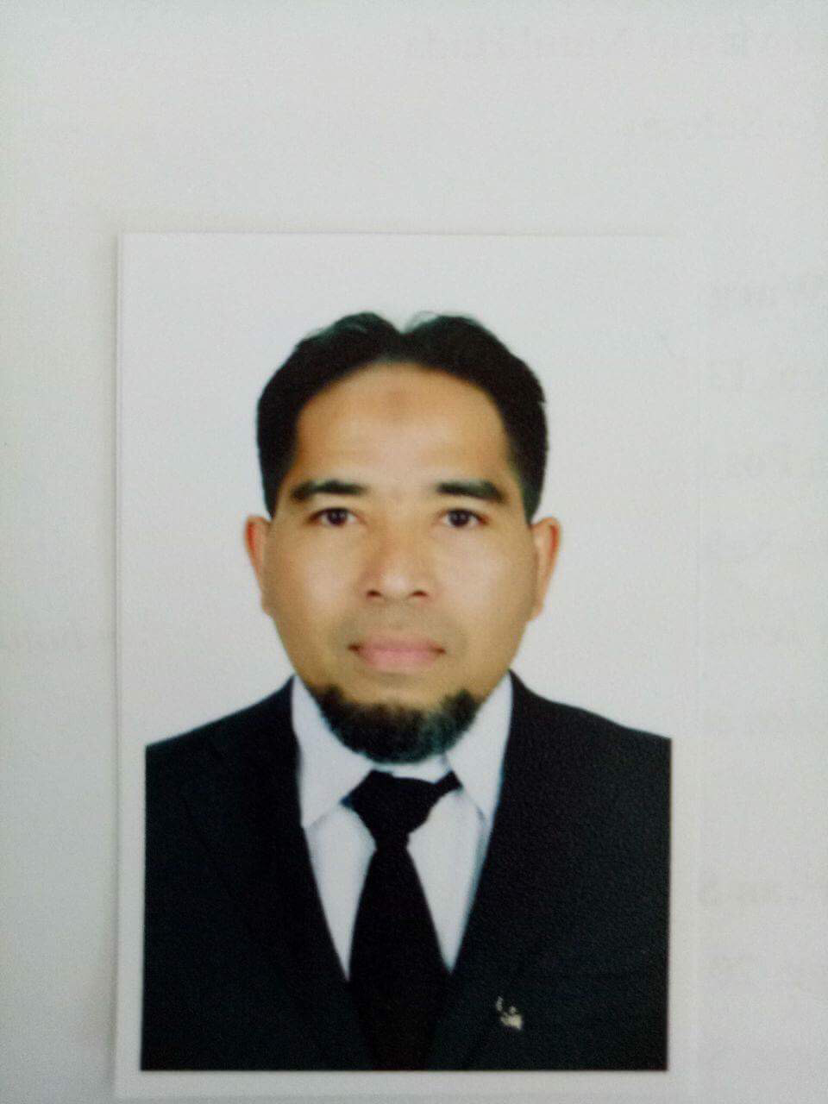
Full Name :Mohamad Ramadhan |  |  | Blood : O |  | High : 162 cm
Date of Birth : September,19,1976 |  |  | Religion : Moslem |  | Weight : 68 kg
Nationality : Indonesia |  |  | E-mail :putra_ramadhan97@ymai putra_ramadhan97@ymail :putra_ramadhan97@ymail putra_ramadhan97@ymail.com |  | Shoes : 39
Gender : Male  Marital Status :Married |  |  | Mobile :  + 62-82170791406 |  | Coverall : M
PERMANENT ADDRESS

Perum Bumisuko Indah blok E2 No 34 RT 44 RW 11 Kelurahan Suko,Kecamatan Sidoarjo, East Jawa, Indonesia. Post code 61224
TRAVEL DOCUMENT
Detail |  | Number | Issued |  |  | Expired Date
 |  |  | Place |  | Date
Seaman Book |  | F 118889 | Surabaya |  | 20 April 2018 | 20 April 2023
Pasport |  | C0266562 | Surabaya |  | 12 April 2018 | 12 April 2023
CERTIFICATE OF COMPETENCY
No. | Detail |  | Number Of  Certificate | Issued |  | Expired Date
 |  |  |  | Place | Date
1. | Deck Officer Class II (Completed Exam) |  |  |  |  | In Process
2. | Deck Officer Class III Management |  | 6200143197M30316 | Jakarta | ^{May 30, 2016} | N/A
3. | Endorsement ANT - III |  | 6200143197MC0316 | Jakarta | ^{June 03, 2016} | ^{23 Juni 2021}
4. | Harbour Craft Master Course  ( MODULE 1 ) |  | ISC-HM06-0100 | Singapore | ^{13 October 2006} | ^{N/A}
CERTIFICATE OF PROFICIENCY
5. | Basic Safety Training |  | 6200143197010320 | Semarang | March 03, 2020 | March, 2025
6. | Proficiency In Survival Craft And Rescue Boats |  | 6200143197040515 | Semarang | March 03, 2020 | March, 2025
7. | Advanced Fire Fighting |  | 6200143197060515 | Semarang | March 03, 2020 | March, 2025
8. | Medical First Aid |  | 6200143197070515 | Surabaya | November 09, 2015 | UNLIMITED
9. | Medical Care On Board Ship |  | 6200143197080316 | Semarang | May 11, 2016 | UNLIMITED
10. | Proficiency in GMDSS |  | 6200143197G10320 | Jakarta | July 13, 2020 | UNLIMITED
11. | Endorsment of GMDSS |  | 6200143197GA0320 | Jakarta | July 16, 2020 | July 16, 2025
12. | General Operator Certificate ( GOC ) |  | 61353/SOU/T/VII/  2017 | Jakarta | July 24, 2017 | July 24, 2022
13. | Ship Security Officer |  | 6200143197240316 | Semarang | May 11, 2016 | UNLIMITED
14. | Radar Simulator |  | 6200143197030316 | Semarang | May 11, 2016 | UNLIMITED
15. | Arpa Simulator |  | 6200143197020316 | Semarang | May 11, 2016 | UNLIMITED
16. | Operational Use Of ECDIS Training Programme |  | 6200143197280316 | Semarang | May 11, 2016 | UNLIMITED
17. | Bridge Resource Management (BRM) |  | 6200143197230316 | Semarang | May 11, 2016 | UNLIMITED
18. | Dangerous,Hazardous&Harmful Cargoes ( IMDG CODE ) |  | 6200143197290515 | Surabaya | March 23, 2020 | March 23, 2025
WORKING EXPERIENCE
COMPANY |  | SHIP | POSITION | KW/HP/GT | PERIOD | FLAG
PSA Marine Singapore |  | Alpha 1 / asd Tug/aqua master | Chief Officer | 2600/3600/ 340 | 20.12.04-11.07.06 | Singapore
PSA Marine Singapore |  | Sea Linsang/asd Tug/aqua master | Chief Officer | 2640/3600/ 342 | 11.07.06-30.08.06 | Singapore
Keppel Smit Towwage Singapore |  | Maju Taurus/asd Tug/Z-peller | Master | 1600/2200/ 210 | 20.11.07-1209.08 | Singapore
Keppel Smit Towwage Singapore |  | Maju Venus/asd Tug/Z-peller | Master | 1600/2200/ 210 | 18.02.09-02.09.09 | Singapore
Keppel Smit Towwage Singapore |  | KST Sirius/asd Tug/aqua master | Master | 2640/3600/ 342 | 03.11.09- 25.06.10 | Singapore
Keppel Smit Towwage Singapore |  | KST Saturn/asd Tug/aqua master | Master | 2600/3600/ 336 | 18.08.10- 03.05.11 | Singapore
Keppel Smit Towwage Singapore |  | Maju Mars/asd Tug/aqua master | Master | 2665/4000/ 380 | 22.06.11-13.10.11 | Singapore
KEPPEL Smit Towwage Singapore |  | Pisces 53/asd Tug/schottel | Master | 4140/5500/ 435 | 14,10.11-08.11.11 | Singapore
KEPPEL Smit Towwage Singapore |  | KST Sunrise/asd Tug/aqua master | Master | 2600/3600/ 340 | 24.04.13- 07.01.14 | Singapore
Keppel Smit Towwage Singapore |  | KST Success/asd Tug/aqua master | Master | 2600/3600/ 340 | 22.04.14- 11.03.15 | Singapore
Kuwait Oil Company |  | KOC al kout/asd work boat | Master | 2136/4200/ 637 | 17.04.15- 17.07.15 | Kuwait
Kuwait Oil Company |  | KOC Saheb/asd Tug/schottel | Master | 4300/5000/ 490 | 05.10.15- 05.03.16 | Kuwait
Kuwait Oil Company |  | KOC al joun/asd Tug/schottel | Master | 2136/4200/  637 | 27.08.16-02.04.17 | Kuwait
Kuwait Oil Company |  | KOC Jawad/ASD Tug | Master | 5400/454 | 04.10.17-30.11.19 | Kuwait

Sincerely yours

MOHAMAD RAMADHAN

